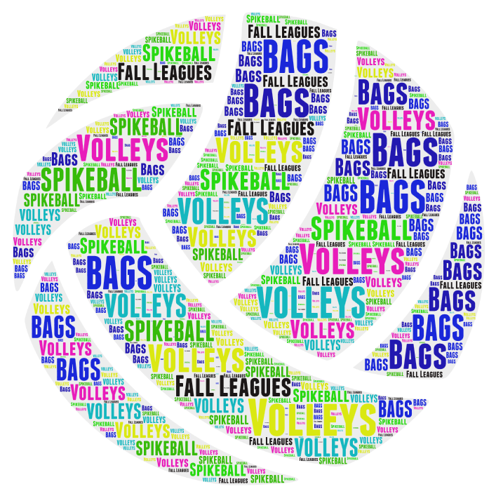
VOLLEYS FALL
BAG LEAGUES
2023

Wednesdays - August 16th, 2023. 2 person teams
($40.00 per team 8 weeks)

BAGS LEAGUE CHOICE: _____7:00 Wednesdays _____8:00 Wednesdays

TEAM NAME:_____________________________________________

SEND ENTRY TO: VOLLEYS

265 BLAIRSFERRY ROAD NE

CEDAR RAPIDS, IA 52402

319-377-9483

VOLLEYS@CRBOWL.COM
P.S. Please remember - we play rain or shine!!!!
TEAM MEMBERS:
NAME: ______________________________
CELL#: ______________________________

NAME: ______________________________
CELL#: ______________________________

